Phase 7 Summary
Construction of the Button-Triggered Capture System + Image Transmission Closed Loop + Final System Validation + Camera Fine-Tuning

Stage Objectives
In the previous phases, the system had already completed the construction of the following key capabilities:
  - PC-side AI inference and binary decision-making;
  - Stable MCU ↔ PC communication closed loop;
  - Custom frame protocol and image chunk transmission;
  - H7 platform migration and modular software architecture reconstruction;
  - OV2640 camera control pipeline and JPEG image acquisition.

Among these achievements, Phase 6 had already verified that:
The MCU was capable of acquiring complete JPEG image data from the OV2640 camera.

However, the image acquisition capability had not yet been integrated into the complete embedded system workflow.

More specifically:
  - The MCU acquisition logic still remained at the stage of automatically capturing a frame after power-on, and a practical acquisition mechanism had not yet been established;
  - The MCU still could not function as an actual system-side data source.

Therefore, the previous system was essentially: “A semi-closed-loop verification system with real input capability.”

Based on this analysis, the core objective of Phase 7 was defined as: Under real hardware input conditions, establish a complete one-button-triggered image acquisition system as a preliminary validation platform for future periodic acquisition systems.

This phase specifically included:
  - Establishing a button-triggered image capture mechanism;
  - Implementing MCU-side JPEG image transmission;
  - Achieving stable image transmission through the communication pipeline;
  - Verifying system stability and recovery capability under real operating conditions.

System Architecture Evolution
Throughout the overall project evolution, the system architecture was not completed all at once. Instead, it evolved progressively according to the goals of each phase.

Its evolution can roughly be divided into three stages:
  - Temporary validation architecture in Phase 4;
  - Real-input validation architecture in the current phase;
  - The final target system architecture.

The final target system architecture
With the completion of Phase 6:
  - OV2640 camera integration;
  - JPEG image acquisition;
  - DCMI + DMA image capture.
For the first time, the ability for the MCU to directly generate “real image data.” As a result, the “Sender” module used in Phase 4 was replaced by “Camera + MCU.”

In this architecture:
  - The Camera is responsible for real image acquisition;
  - The MCU handles JPEG acquisition and transmission;
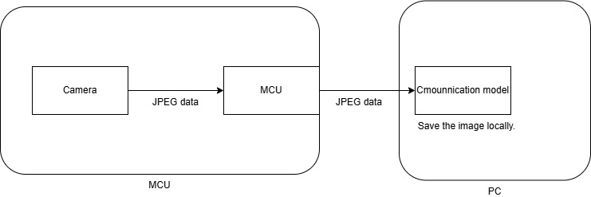
  - The PC-side Communication Model receives and stores the image.
The system data flow became:
Camera → MCU → Communication Model

Therefore, the core objective also shifted toward validating the real input system itself, focusing on:
  - Camera acquisition stability;
  - JPEG generation stability;
  - MCU transmission capability;
  - One-button-triggered system behavior;
  - Long-term operational stability.

In Phase 4, the system had already completed:
  - Image chunk transmission;
  - TCP/UART dual-channel communication;
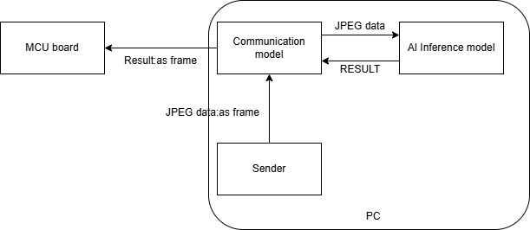
  - Image reassembly and AI closed-loop verification.
However, the communication behavior at that time was essentially: “One-time validation-style communication.”

That is:
  - Sender starts;
  - Images are sent sequentially;
  - Communication model receives them;
  - Process terminates.

This structure could verify whether the communication link itself worked, but did not consider stability under repeated operation.

With the introduction of MCU-initiated image transmission and repeated button-triggered capture in this phase, the system entered a: “Restart-and-run style input system.”

As a result, synchronization and repeated-session issues were exposed for the first time.

Startup Timing Problem
Initially, the MCU immediately entered: “Capture → JPEG Transmission” after startup.

However, during real operation it was discovered that: The startup speed of the PC-side Communication Model and the MCU does not match.

Specifically:
  - The MCU began transmitting JPEG data immediately after startup;
  - The PC communication module might not yet have completed serial initialization;
  - Resulting in partial data loss or reception failures.

This problem belonged to: Communication trigger timing issues.

Establishment of the Handshake Mechanism
To solve this issue, an explicit handshake mechanism was introduced for the first time.

Its core objective was: Before image transmission begins, confirm that the PC side has entered a ready-to-receive state.

The communication flow was modified as follows:
MCU Startup → Send STANDBY → PC Returns READY → MCU Allowed to Start JPEG Transmission

That is: Only after the PC explicitly returns READY is the MCU allowed to start JPEG transmission.

Through this mechanism:
  - Startup timing synchronization issues were resolved;
  - A clear synchronization relationship between MCU and PC was established;
  - UART chunk transmission became stable;
  - The underlying frame protocol and image reconstruction mechanisms operated correctly;
  - JPEG data no longer suffered truncation or corruption;
  - The system evolved from “occasionally successful” to “reliably repeatable.”

Repeated Operation Mechanism
After the handshake mechanism was completed, the system could reliably complete one JPEG transmission. However, with the introduction of repeated button-triggered capture, another issue emerged: The Communication Model exited immediately after receiving one JPEG image.

Although suitable for one-time validation, this architecture could not support a repeated-capture system.

Therefore, the Communication Model was redesigned, after JPEG reception:
  - The program no longer exits automatically;
  - The communication main loop remains active.
Instead, it returns to: STANDBY state.

The new operating procedure is:
STANDBY → Receive JPEG → Processing Complete → Return to STANDBY

The establishment of this mechanism marked the first time the system truly possessed: Repeated trigger-based operational capability.

End Handshake Mechanism
To facilitate camera debugging, an image length accounting mechanism was added.

Its purpose was to output:
  - capture_len;
  - tx_len;
  - pc_received_len;
  - saved_file_size.
after JPEG reception completed.

But this introduced a new protocol issue: Previously, the JPEG EOF frame implicitly represented Session End.

But after adding the accounting mechanism, the system still needed to perform:
  - Length statistics;
  - Debug output;
  - Data verification.
after JPEG transmission completed.

Therefore: “JPEG End” no longer equaled “Session End.”

Thus, The End Handshake mechanism was introduced:
JPEG EOF → Length Accounting → Debug Output → END Handshake (TX_DONE) → Session Close

The communication protocol therefore began to possess: A more complete session lifecycle semantic structure.

Establishment of the Button-Triggered Capture System
In Phase 6, the system had already completed:
  - OV2640 initialization;
  - DCMI + DMA image acquisition;
  - JPEG data capture.

However, the acquisition logic at that time was:
MCU power-on → Camera initialization → Automatic one-frame JPEG capture → Program ends

This structure could verify: Whether the MCU was capable of acquiring real image data. The stable relationship between: “Input Event → Image Acquisition → Communication Behavior” had not yet been established.

Therefore, in entering the real input system stage, the first question became: When should the system capture images?

In the final target system, the camera should not continuously capture images unconditionally. Instead, image acquisition should be triggered by:
  - User input;
  - Timers;
  - Or other external events.

So, this phase first established: A button-triggered acquisition model.

The system began abstracting physical button behavior into System input events.

The basic process became:
KEY EVENT → Start JPEG Capture → Wait for Capture Completion

Decoupling Acquisition and Transmission
During implementation, the system reused the previously established button event model:
KEY_IDLE → PRESS → RELEASE → EVENT

However, instead of immediately constructing a “one-button capture-and-upload system,” image capture and image transmission were first separated into two independent events for easier debugging and issue localization.

The system adopted:
  - One button for JPEG capture;
  - Another button for JPEG transmission.

That is:
  - KEY_CAPTURE → Capture JPEG into Buffer;
  - KEY_SEND → Read Current JPEG Buffer and Transmit.

The core purpose of this design was to clearly separate:
  - Whether the MCU had correctly generated the image;
  - Whether the image became corrupted during communication.

This design allowed:
  - Freezing and repeatedly transmitting the same JPEG;
  - Independent validation of acquisition results;
  - Elimination of communication chain interference during debugging;
  - Avoidance of coupling caused by simultaneous capture and transmission.

Frame-Event-Based Acquisition Mechanism
During repeated capture experiments, it was observed that: Images gradually developed color distortion after repeated captures.

At the time, the system used the same time-window-based acquisition mechanism as the open-source reference project:
HAL_Delay() → HAL_DCMI_Stop()

That is: Capture termination relied on fixed timing rather than actual frame completion events.

It was suspected that this might be the reason of image distortion.

Therefore, a new experimental function was introduced: CameraCapture_SnapshotByFrameEvent(). In this mode: The system automatically stopped DCMI after receiving a complete frame event.

Continuous experiments showed:
  - The FrameEvent chain triggered reliably;
  - JPEG boundaries remained correct;
  - Image transmission results remained consistent.

However: Image distortion still persisted.

So, it was confirmed that: Fixed time-window truncation was not the primary cause of image distortion.

Nevertheless, the system thereby gained: True frame-event-driven acquisition capability.

Reintegration into the Closed-Loop System
After camera debugging stabilized, image acquisition and image transmission were re-coupled.

The system flow became:
KEY EVENT → JPEG Capture → JPEG Transmission → PC Reception

That is: One-button capture and upload.

Investigation and Root Cause Localization of the Image Distortion Problem

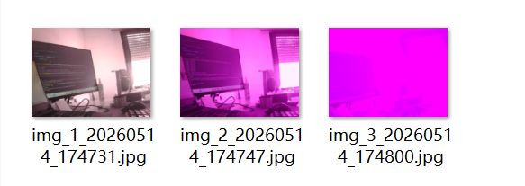
The first captured image was usually mostly normal. However, after repeated captures, the images gradually developed strong red, green, or purple color distortions. The severity increased with the number of captures, and in extreme cases the images became nearly unrecognizable. At the same time, the JPEG file size progressively decreased.

This phenomenon indicated that the issue was not a simple “image generation failure” or “communication failure.” Instead, the system was experiencing a far more subtle form of state drift:

The JPEG structure itself remained valid, but the image quality continuously deteriorated over time.

Initial Suspicion: JPEG Buffer Residue and Premature Frame Truncation
After the issue first appeared, the initial hypothesis was: Residual data from the previous frame remained inside the JPEG buffer, causing the new frame to prematurely encounter an old EOI (End of Image) marker during scanning, which resulted in JPEG truncation.

To verify this, the MCU-side buffer lifecycle was carefully inspected. It was confirmed that:
  - The entire frame buffer was fully cleared before each capture;
  - cam_frame_buffer used a complete 256KB buffer rather than partial clearing.

Therefore, there was insufficient evidence supporting the hypothesis that: “Old EOI markers remaining in memory caused premature JPEG truncation.”

Further debugging logs were then added to observe:
  - SOI index;
  - EOI index;
  - JPEG length;
  - VALID status;
  - DCMI/DMA status.

The results consistently showed:
  - SOI always appeared stably at index = 0;
  - EOI could always be correctly located;
  - The system continuously generated valid JPEG files.

This demonstrated that the issue was not a typical JPEG marker corruption or buffer residue problem.

Verification of the Capture Completion Mechanism
At the time, the Snapshot acquisition logic directly followed the timing-based mechanism used in the open-source reference project:
HAL_Delay() → HAL_DCMI_Suspend() → HAL_DCMI_Stop()

Therefore, another suspicion emerged: The DCMI might not have completed acquisition of a full JPEG frame before capture was forcibly stopped, causing the resulting JPEG to possess valid boundaries while still containing incomplete image data.

To test this possibility, the acquisition delay was successively increased to:
  - 1000 ms
  - 1500 ms
  - 2000 ms

However, the distortion problem still persisted. This proved that: Simply extending the acquisition window could not resolve the issue.

A frame-event-driven capture mechanism was then introduced. Under this new mechanism, the system only allowed DCMI stopping and JPEG processing when:
  - done == 1;
  - error == 0;
  - timeout == 0.

Experimental results showed:
  - The FrameEvent callback chain triggered reliably;
  - JPEG boundaries remained valid;
  - Transmission results remained consistent.
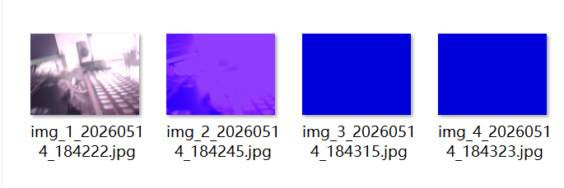
But the image distortion still occurred.

Therefore, it could be conclusively determined that: The primary cause of the distortion was not the fixed time-window capture mechanism.

Investigation of the Communication Pipeline
After excluding both buffer residue and capture completion timing as causes, suspicion shifted toward the communication pipeline.

Specifically, it was considered possible that corruption occurred during:
  - Image transmission;
  - Chunk segmentation;
  - Image reconstruction;
  - File saving.

To verify this, a four-way accounting mechanism was introduced:
  - capture_len: actual valid JPEG size on the MCU side;
  - tx_len: actual number of bytes transmitted by the MCU;
  - pc_received_len: actual reconstructed image size on the PC side;
  - saved_file_size: final saved file size on the PC.

Repeated experiments consistently showed:
capture_len = tx_len = pc_received_len = saved_file_size

Additionally:
  - Chunk count remained correct;
  - last_chunk_size behaved normally;
  - image_id remained stable;
  - Sequence numbers were correct.
No abnormalities were observed.

Therefore, the following components could essentially be ruled out:
  - Communication transmission;
  - Chunk segmentation;
  - PC-side reconstruction;
  - File saving.

This proved that: The image distortion was already present before the JPEG entered the communication pipeline.

Investigation of OV2640 and DCMI/DMA Residual State Problems
Because the distortion clearly exhibited characteristics of progressive state drift:
  - The first image was normal;
  - Subsequent images gradually shifted in color;
  - Distortion accumulated over time.

it became strongly suspected that: Internal OV2640 JPEG/ISP/output states were not being properly reset between captures.

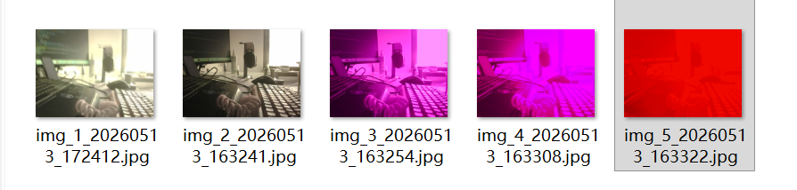
The first attempt was therefore to perform the following sequence after each capture:
OV2640 Hardware Reset → OV2640_Init_1280x960_JPEG → LightMode Initialization

This demonstrated that: Ordinary OV2640 hardware reset or register reinitialization alone was insufficient.

Attention then shifted toward the DCMI/DMA acquisition pipeline.

It was suspected that: Residual DCMI/DMA state machines accumulated over repeated captures.

Three levels of reset strategies were designed:
  - Lightweight reset;
  - Medium reset;
  - Full reset.

including operations such as:
  - Stop DCMI;
  - Abort DMA;
  - Clear Flags;
  - DCMI/DMA DeInit + Init;
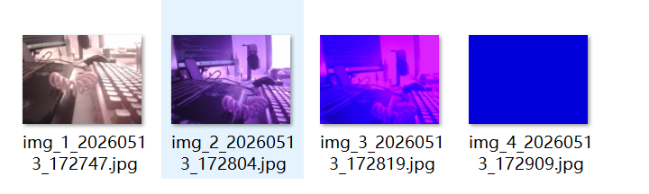
  - Peripheral force reset.
DCMI Reset Medium

Experimental results showed that: None of these approaches resolved the distortion problem.

Full Acquisition Chain Rebuild and Identification of the Critical Recovery Mechanism
After failing to explain the issue through:
  - Communication pipeline problems;
  - Buffer residue;
  - JPEG boundary errors;
  - Capture timing;
  - DCMI/DMA reset;
  - Ordinary OV2640 reset.
the debugging strategy changed to: “Expand the reset scope first, then progressively narrow it down.”

Thus, after image transmission completed, the system began performing a near-complete reconstruction of the acquisition chain:
Stop DCMI → Abort DMA → DCMI/DMA ReInit → I2C/SCCB Rebuild → PWDN PowerDown/PowerOn→ OV2640 Hardware Reset → OV2640 JPEG Init → LightMode Init → Clear FrameBuffer

Experimental results showed: The Full Acquisition Chain Rebuild significantly reduced the accumulation of blue-screen, purple-screen, and severe color distortion phenomena.
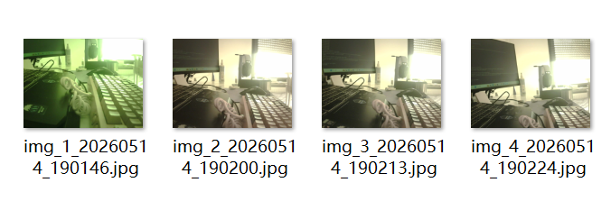
Additionally:
- JPEG size no longer collapsed dramatically;
- Continuous-capture stability improved significantly.

Subtraction experiments were then performed:

Since DCMI/DMA reset and ordinary OV2640 reset had already been independently proven ineffective, components were progressively removed from the recovery chain.

Eventually, it was discovered that the truly critical recovery mechanism was: PWDN PowerDown / PowerOn

When this step was removed:
  - Severe color distortion immediately returned;
  - Large-scale color contamination reappeared;
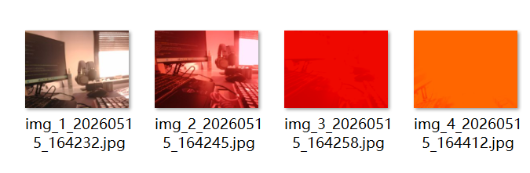
  - JPEG size rapidly collapsed again.
Yet:
  - JPEG structure remained valid;
  - SOI/EOI markers were still correct;
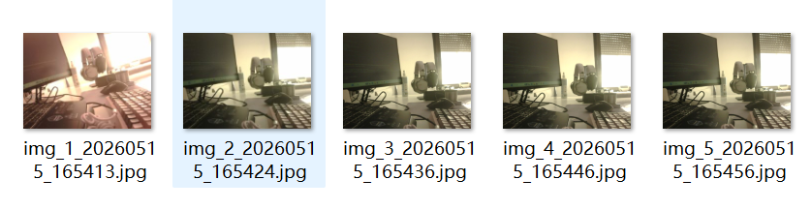
  - Communication accounting remained perfectly consistent.

This demonstrated that: The issue was neither a communication failure nor an MCU-side acquisition failure.

Instead: The internal output state of the OV2640 itself was drifting into an abnormal condition.

Final Root Cause: Internal ISP/AWB State Drift in OV2640
All previous observations were then reanalyzed, and further white-balance experiments were conducted.

The results strongly indicated that: The core issue was highly concentrated around the OV2640 internal Auto White Balance (AWB) mechanism.

When PWDN reset was disabled: Distortion reappeared.

After then, fixed white-balance modes such as:
  - CLOUDY
  - SUNNY
  - OFFICE
  - HOME
were tested.

Under these fixed modes:
  - Images still exhibited static color bias;
  - However, image structure remained stable;
  - JPEG size remained stable;
  - Progressive collapse no longer occurred;
  - Random large-scale color contamination disappeared.

This proved that: Fixed white-balance modes significantly suppressed cumulative state pollution.

Therefore, the issue clearly did not originate from:
  - UART
  - DCMI/DMA
  - JPEG structure
  - Communication pipelines
but rather from: Internal ISP/AWB state drift occurring specifically under OV2640 AUTO white-balance mode.

Further two new white balance functions were tested:
  - OV2640_AdvancedWhiteBalance();
  - OV2640_SimpleWhiteBalance().

Its characteristics included:
- Stable image boundaries;
- Relatively natural colors;
- No progressive state contamination;
- Stable JPEG size;
- Highest overall consistency.

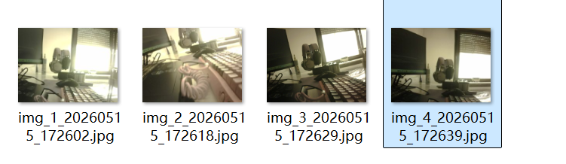
Thus: OV2640_SimpleWhiteBalance() was selected as the default acquisition baseline.

At the same time, an additional Soft Reset function was discovered in the open-source project. Under AUTO mode testing:
  - It could not completely eliminate distortion;
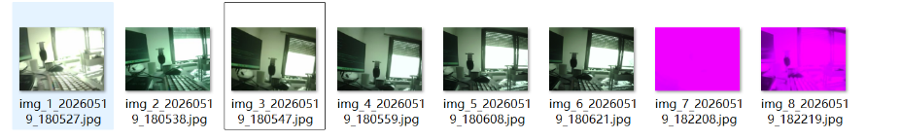
  - But it significantly delayed the onset of ISP/AWB state contamination.

The white-balance algorithms and Soft Reset implementation referenced the following open-source project:
https://github.com/SimpleMethod/STM32-OV2640/tree/master

Final Conclusion of This Investigation
After extensive experiments, it was ultimately confirmed that the image distortion problem was NOT caused by:
  - JPEG buffer residue;
  - JPEG marker scanning errors;
  - UART communication abnormalities;
  - Chunk segmentation or PC-side reconstruction errors;
  - Simple DCMI/DMA residual state accumulation;
  - Incomplete frames caused by Snapshot fixed-time capture.

Instead, the root cause was conclusively identified as: Internal ISP/AWB/JPEG pipeline state drift occurring inside the OV2640 during repeated captures, strongly correlated with the AUTO white-balance mechanism.

The reason why PWDN PowerDown / PowerOn proved effective is that:

It behaves similarly to a full camera power cycle, clearing internal ISP, AE, AWB, JPEG pipeline, and color-matrix states inside the OV2640.

Exception Detection, Recovery, and Feedback Mechanism
After the image distortion issue had been narrowed down and identified, the system confirmed that the root cause originated from: Internal ISP/AWB state drift inside the OV2640 camera.

At the same time, repeated continuous-capture experiments revealed another important characteristic: System failures were not entirely random, but instead exhibited a clear process of gradual degradation.

This degradation typically manifested as:
  - Progressive reduction of capture_len;
  - Gradual color shifting;
  - Decreasing JPEG information density;
  - Continuous deterioration of image quality;
  - Eventually entering severe color contamination or unstable exposure states.
As a result, the focus of the project began to shift.

The system now required more than simply: “Being able to capture images.”

It also needed the capability to support:
  - Exception detection;
  - Automatic recovery;
  - Session isolation;
  - Exception-state feedback;
  - Long-term operational stability.

Consequently, the core problem evolved from “How to locate the issue” into “How the system can continue operating stably under abnormal conditions.”

Establishment of the Fail-Fast Cleanup Mechanism
After the system architecture evolved from “KEY1 for capture / KEY0 for transmission” to “Single-button capture + transmission,” a new issue emerged.

Previously, the buffer cleanup logic only existed inside the: Normal successful transmission path.

That is, cleanup operations were only executed when: tx_status == HAL_OK
under which the system performed:
  - Buffer cleanup;
  - Session termination;
  - State reconstruction.

However, abnormal paths such as:
  - UART transmission failure;
  - PC READY handshake failure;
  - ACK timeout;
  - JPEG abnormalities.
did not trigger any cleanup behavior.

Under the earlier decoupled architecture: “KEY1 capture / KEY0 transmission,” this problem was less noticeable.

But under the current: “Single-button full-session workflow,” failed sessions could potentially cause:
  - Buffer state contamination;
  - Residual session states;
  - JPEG overwrite anomalies;
  - Unpredictable behavior in subsequent sessions.

To prevent these problems, the system introduced the: Fail-Fast Cleanup mechanism.

Under this mechanism, all abnormal execution paths—including:
  - Capture failure;
  - PC handshake failure;
  - JPEG transmission failure;
  - TX_DONE failure;
  - ACK timeout failure.
would immediately enter a unified: fail_cleanup path.

The final cleanup actions included:
  - CameraCapture_ClearBuffer();
  - g_trigger_img_ready = 0;

This guaranteed that: Failed sessions could never contaminate subsequent sessions.

Establishment of the capture_len Health Monitoring
After the Fail-Fast Cleanup mechanism was established, the system began reconsidering another important issue:

Although the image distortion problem had been temporarily mitigated through the use of SimpleWhiteBalance as a stable baseline, and no obvious distortion had been observed during repeated testing, it was still impossible to guarantee that similar problems would never reappear during long-term operation.

Therefore, the system required a dedicated: “Detection → Recovery” mechanism specifically targeting this class of ISP/AWB instability.

Initially, the variable capture_len was only used as a JPEG length statistic for:
  - MCU ↔ PC length verification;
  - JPEG integrity validation;
  - Debug output.

However, after extensive experimentation, an important pattern gradually emerged:
  - Normal images usually produced: capture_len ≈ 45KB ~ 70KB
  - Severely abnormal images frequently dropped to: capture_len ≤ 40KB

At the same time, these low-length images were consistently associated with:
  - Large-scale color contamination;
  - Significant loss of image information.

Therefore, the role of capture_len was upgraded from “Communication statistic” to “ISP state health indicator.”

The system formally established the following interpretation:
  - capture_len within normal range → ISP state considered healthy
  - capture_len < threshold → Current image classified as abnormal

Two-Level Recovery Architecture
After confirming that PWDN Power Cycling could effectively restore ISP/AWB stability, the system proceeded to design an automatic recovery mechanism.

However, directly performing a PWDN hard reset every time an abnormality was detected was considered too costly because:
  - Re-powering the OV2640 disturbed its internal state;
  - AE/AWB/ISP pipelines required time to reconverge;
  - The first few frames after power-on often remained unstable.

Therefore, instead of immediately executing a hard reset after detecting abnormalities, the system adopted a: “Soft Reset → PWDN Recovery” two-level recovery architecture.

The final recovery process became:
  - If capture_len < threshold → classify as ISP abnormal → trigger Soft Reset
  - On the next capture:
    - If capture_len still remained below threshold → classify Soft Reset as failed → trigger PWDN hard recovery
    - If capture_len returned to normal → exit recovery state

Extreme stress tests were then performed under AUTO_MODE, and the threshold was gradually adjusted upward to approximately 40KB.

The results showed:
  - The mechanism successfully prevented catastrophic image collapse;
  - Distortion severity was significantly reduced;
  - JPEG sizes of already-distorted images were constrained to approximately 40KB–45KB;
  - However, distortion could still occur around the 45KB region;
  - Further increasing the threshold risked introducing false positives.

Since this mechanism was ultimately intended as a fallback safeguard, and the system had already adopted OV2640_SimpleWhiteBalance() as a stable operating baseline, the mechanism was considered sufficiently effective and was no longer further optimized.

Integration of Health Monitoring into the Fail-Fast Cleanup Mechanism
After the capture_len health monitoring mechanism had been established, the system reevaluated its placement within the session lifecycle.

Although capture_len became available immediately after image capture, the system originally performed abnormality checks only: After image transmission had already completed.

This meant that:
Even obviously distorted images could still enter the PC communication pipeline, become saved locally, and potentially even proceed into the AI inference pipeline.

At the same time, the existing Fail-Fast Cleanup mechanism was still primarily focused on: “Cleanup after communication failure.”

It could already respond to:
  - Capture failure;
  - Transmission failure;
  - Session interruption;
  - READY handshake failure.

by immediately performing:
  - Buffer cleanup;
  - Session termination;
  - Return to idle state.

However: Image health validation had not yet been integrated into the session lifecycle.

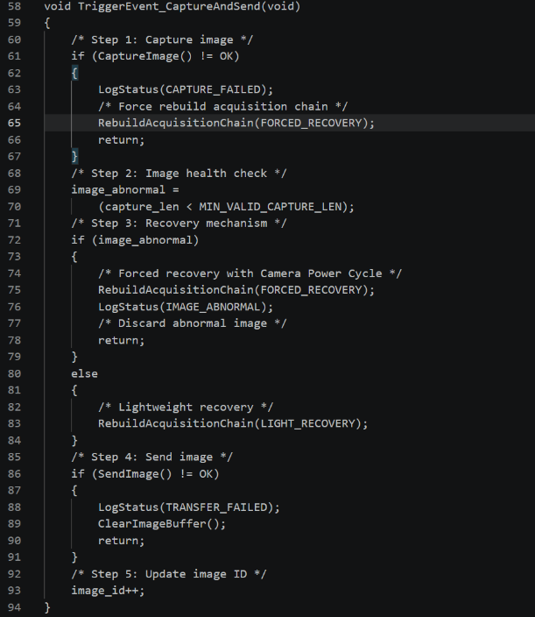
Therefore, the system formally integrated: “capture_len health monitoring and recovery.” into the Fail-Fast Cleanup architecture.
Code logic display

The system workflow was restructured into:
Capture → Frame Validation Gate → Transmission

Before transmission was allowed, every image was required to pass through a: Frame Validation Gate.

The current validation stage included checks for:
  - JPEG SOI/EOI validity;
  - capture_len range;
  - Frame status;
  - Communication link status.

Only when all conditions passed could the image proceed into transmission.

Otherwise: The current session immediately entered the Fail-Fast Cleanup path.

This change fundamentally transformed the role of capture_len.

It was no longer merely: “Post-event statistical information,” but instead became: A core component of the image admission control mechanism.

Reorganization of the Exception-State System
The system ultimately formalized three categories of abnormal states:
- CAPTURE_FAILED
- Meaning:
    - Image acquisition failed;
    - JPEG was not generated;
    - capture_len == 0
- Current behavior:
    - Clear buffer;
    - Rebuild acquisition chain;
    - Return to idle state.
- IMAGE_ABNORMAL
  - Meaning:
    - Image acquisition technically succeeded.
    - But:
      - capture_len fell below threshold;
      - ISP state became abnormal;
      - Frame classified as corrupted.
  - Current behavior:
    - Discard current image;
    - Clear buffer;
    - Trigger:
      - Soft Reset;
      - PWDN Recovery.
    - Return to idle state.
- TRANSFER_FAILED
- Meaning:
    - The image itself was valid;
    - But:
      - PC READY handshake failed;
      - UART transmission failed;
      - ACK timeout occurred;
      - Session was abnormally interrupted.
- Current behavior:
    - Clear buffer;
    - Terminate current session;
    - Return to idle state.

Establishment of the Exception Feedback Mechanism
After the abnormal-state architecture was completed, additional extreme stress testing was conducted under AUTO_MODE.

At this point, although the MCU internally already possessed:
  - Exception detection;
  - Automatic recovery;
  - Session termination.
the PC side still had no visibility into what had actually occurred.

From the PC perspective: It simply appeared that no image had been received during the current session.

Therefore, an MCU → PC exception feedback mechanism was introduced.

The system established three exception messages:
  - [CAPTURE_FAILED]
  - [IMAGE_ABNORMAL]
  - [TRANSFER_FAILED]

During subsequent stress tests, the system quickly and successfully triggered:
  - IMAGE_ABNORMAL
  - CAPTURE_FAILED

while simultaneously verifying that:
  - Abnormal sessions could terminate correctly;
  - The system could automatically recover afterward;
  - Subsequent normal JPEG images could still be transmitted successfully;
  - No state contamination occurred between sessions.

At this point: The system officially achieved abnormal-state visualization.

System Behavior Evolution
The current system now possesses:
  - Health-state monitoring;
  - Automatic recovery;
  - Fail-fast exit behavior;
  - Session isolation;
  - Exception classification;
  - State feedback;
  - Long-term operational capability.

The system has therefore begun transitioning from: “A functional validation system” toward: “A true long-term-operational real-input system.”

First-Frame Color Shift and ISP Convergence Phenomenon
During the experiments described above, another phenomenon was discovered:
  - The first few images captured after power-on exhibited slight color shifts and exposure instability;
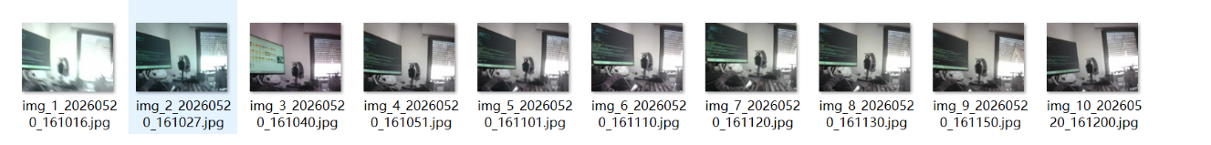
  - Subsequent images gradually returned to normal.
This phenomenon differed significantly from the previously observed severe progressive corruption.

In the current case:
  - The image scene itself remained recognizable;
  - Only the color matrix and exposure appeared slightly abnormal;
  - The issue occurred only during the first few frames after startup;
  - Later frames stabilized automatically.

Based on these observations, it was hypothesized that:
After being powered on, the OV2640 internal AE (Auto Exposure), AWB (Auto White Balance), and ISP pipelines require several frames to converge into a stable operating state.

Introduction of the Warm-up Frame Mechanism
To verify this hypothesis, a Warm-up Frame mechanism was introduced.

The basic idea was:
After powering on the OV2640, the system would automatically capture several preliminary frames and discard them before generating the first “official” image.

Based on previous experimental observations, image stability generally converged around the fourth frame. Therefore: The number of Warm-up Frames was set to 3.

The system workflow became:
OV2640 Power-On → Capture Warm-up Frames → Discard Warm-up Frames → Begin Official Image Acquisition

Experimental Results
After applying this mechanism, the following improvements were observed:
  - The first official image still exhibited slight exposure fluctuation
  - However, convergence speed improved significantly;
  - The second image typically returned fully to normal;
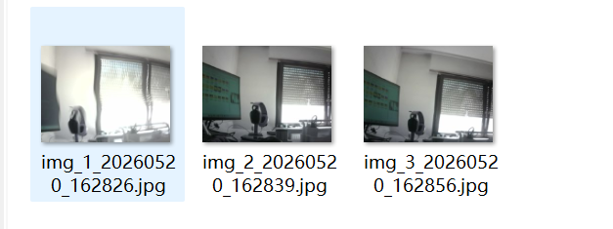
  - Subsequent images remained stable overall

These results suggested that:
The remaining minor deviations should now be regarded as the natural AE/AWB convergence behavior of the OV2640 under real-world lighting conditions, rather than a system-level fault.

Integration of the PC-Side Reception and AI Inference Pipeline
During this phase, the AI inference module was also integrated into the communication system for preliminary testing. These experiments verified that:

The communication subsystem was capable of correctly receiving and processing AI inference results.

However, at the current stage, the AI pipeline was not incorporated into the primary experimental workflow.

The main reasons were:
  - Real insect specimens had not yet been obtained;
  - AI experiments using printed insect images did not possess meaningful real-world application value.

Therefore, during this phase, the following decisions were made temporarily:
  - The AI Inference Model was removed from the active runtime workflow;
  - MCU-side RESULT feedback logic was not yet implemented.

Nevertheless:
The AI closed-loop communication module was preserved and archived as a stable baseline implementation.

Introduction of the AI-Agent-Assisted Development Workflow
As the system complexity continued to increase, the previously adopted development model gradually became insufficient for the project’s needs.

The original workflow primarily relied on:
  - Human-led system architecture design;
  - Detailed mechanism and framework design;
  - Manual code implementation;
  - Context management;
  - Engineering document lookup;
  - Repetitive debugging.

while conventional conversational AI tools were mainly used only for:
  - Code generation assistance;
  - Problem analysis;
  - Documentation lookup.

During the previous phase, it became increasingly clear that this development model was reaching its practical limits.

Therefore, in response to the growing engineering complexity, this phase formally introduced: An AI-Agent-based development workflow using Large Language Model agents (Codex).

Primary Roles of the AI Agent
At the current stage, the AI Agent mainly participates in the following tasks:
  - Engineering code structure organization;
  - Code generation;
  - Engineering comment completion;
  - Module dependency and call-chain analysis;
  - Project structure migration.

During development in this phase, the Agent significantly improved:
  - Modular development efficiency;
  - Engineering structure organization efficiency;
  - Code analysis efficiency during debugging.

Formation of a New Collaborative Development Model
A new collaborative workflow gradually emerged during this phase.

Human Responsibilities
The developer primarily remained responsible for:
  - System architecture design;
  - Mechanism and framework design;
  - Debugging direction selection;
  - Information-flow filtering;
  - Code review;
  - Engineering-level decision making;
  - Root-cause analysis of problems.
In other words: Humans remained responsible for system-level judgment and engineering decisions.

AI Agent Responsibilities
The AI Agent primarily handled:
  - Code writing;
  - Repetitive debugging tasks;
  - Rapid experimental validation;
  - Code analysis.
That is: The Agent became responsible for high-frequency trial-and-error operations and large-scale information processing.

Conversational AI Responsibilities
At the same time, conventional conversational AI tools were mainly used for:
  - Engineering document and text management;
  - Theoretical validation of system structures;
  - Validation of mechanisms and architectural concepts;
  - Auxiliary problem analysis;
  - Auxiliary code analysis.

Development Efficiency Improvements
This collaborative development model significantly improved overall development efficiency.

Tasks that previously required several days to complete—such as:
  - Multiple rounds of reset experiments;
  - Parameter validation;
  - Communication-chain reasoning and verification.
could now often be completed within a single day.

At this stage, the project began to demonstrate a new collaborative paradigm:
Humans handle system-level reasoning and decision-making, while AI systems handle high-frequency experimentation and information processing.

Phase Conclusion
At the current stage, development of the button-triggered image capture system as a validation platform has been largely completed.

Only the following experiments remain pending the arrival of real insect specimens:
  - Real target validation;
  - YOLO inference testing;
  - AI result verification;
  - Development of MCU-side behavior after receiving RESULT messages.

At the same time, the preliminary validation work for the future periodic acquisition system has, in practice, already been largely completed during this phase.

The current system has successfully completed:
  - Continuous image acquisition validation;
  - Session lifecycle validation;
  - Exception recovery validation;
  - Long-term JPEG stability validation;
  - Communication pipeline stability validation;
  - Automatic recovery mechanism validation;
  - State isolation validation.

Next Phase
The next phase will officially begin: Development of the periodic acquisition system.

The primary focus areas of the next stage include:
  - TIM-based periodic triggering;
  - Session scheduling mechanisms;
  - Watchdog mechanisms;
  - Long-term stability verification;
  - MCU ↔ PC ↔ AI periodic closed-loop operation;
  - Real insect specimen experiments;
  - AI inference optimization;
  - Final system integration.

